How to Build DWIN Software Running Environment

If the DWIN DGUS software cannot be opened normally, you need to install the .NET running environment.

You need to download environment before install it.
First, you need to check whether your computer is 32bit or 64bit. If it is 64bit, select x64, if it is 32bit, select x86.

Both installation methods are the same

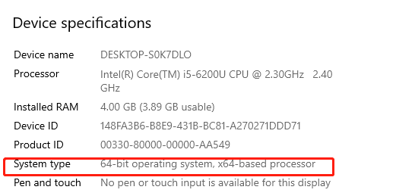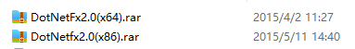

After selecting the correct installation package, unzip it.
Then click on the installation package to install the environment.

Download the files through DWIN official website: https://www.dwin-global.com/tool-page/

